## Application Previews

### Room Add Page

### List Rooms Information Page

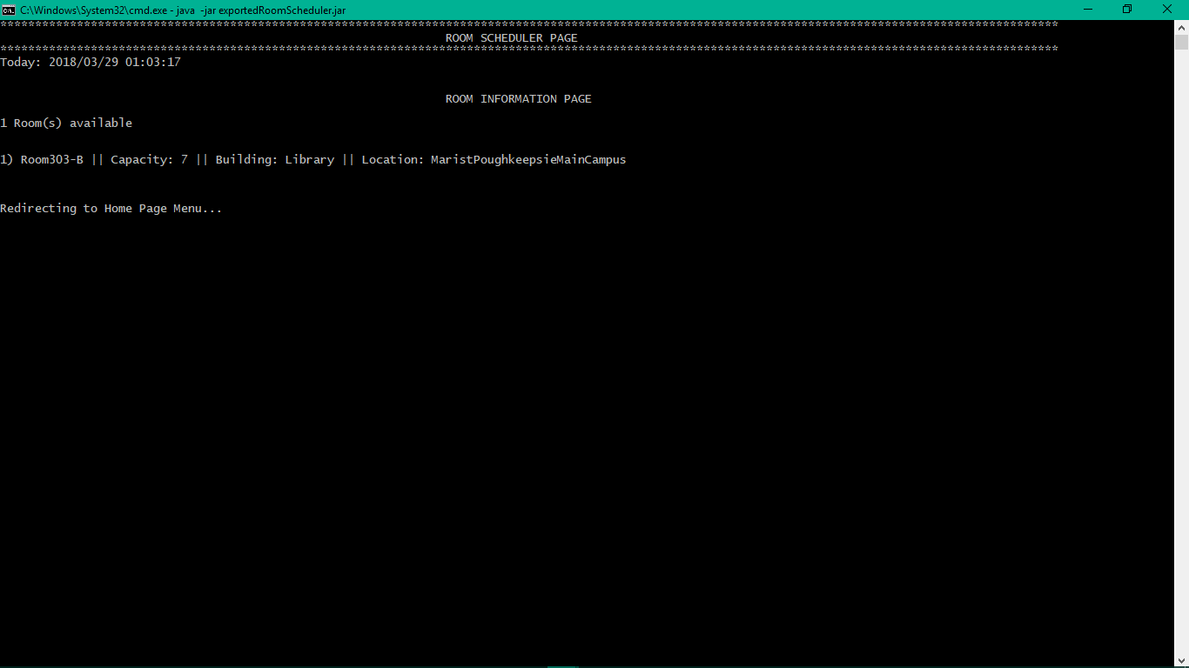

### Room Schedule Page

### Scheduled Room Info Page

## UNIT TESTING RESULTS

As of 29th March 2018. (Refer the Maven SureFire Report section below STATIC TOOL ANALYSIS in this document titled “Take 2: as of 29th March 2018” to view the test site output)

Maven Results

-------------------------------------------------------

T E S T S

-------------------------------------------------------

Tests run: 13, Failures: 0, Errors: 0, Skipped: 0, Time elapsed: 0.608 sec

Running test.java.RoomTest

Tests run: 10, Failures: 0, Errors: 0, Skipped: 0, Time elapsed: 0.001 sec

……

Results :

Tests run: 23, Failures: 0, Errors: 0, Skipped: 0

……

[INFO] ------------------------------------------------------------------------

[INFO] BUILD SUCCESS

[INFO] ------------------------------------------------------------------------

[INFO] Total time: 27.485 s

[INFO] Finished at: 2018-03-29T01:42:05-04:00

[INFO] Final Memory: 40M/317M

[INFO] ------------------------------------------------------------------------

## Maven SureFire Report

### Take 2: as of 29th March 2018